Cognos Beginner Guide

# Purpose

The purpose of this guide is to teach users how to use Cognos. This includes how to navigate within the tool, run and subscribe to reports, and view dashboards. Subscribing gives a user the ability to schedule a report to run on a specific day and time and email it to themselves.

This document is a companion to the PowerPoint presentation that discusses data security and Cognos packages. This guide details the Cognos training that is done live in the tool and not documented in the PowerPoint. The attendee can refer to this document on their own later when using Cognos for the first time.

Contents

Purpose 1

Prerequisites 2

Definitions 2

Log In to Cognos 3

Prerequisites 3

Troubleshooting Log In 3

Steps 4

Log out of Cognos 5

Cognos Application Bar Overview 5

Home Page Overview 8

My Schedules and Subscriptions Page Overview 11

Open Menu Overview 14

Navigating Cognos 14

Find/Search for a Report 16

View a Recent Report 18

Troubleshooting 19

View a Report 20

Export a Report 22

Report Page Overview 23

Modify an Interactive Report 26

Create a Subscription (Schedule a Report) 37

View a Subscription 39

Edit a Subscription 41

Delete a Subscription 46

View and Interact with a Dashboard 48

Request Access to Cognos 49

Where to Get Help 50

# Prerequisites

* Chrome browser is required to use Cognos. Cognos may not function properly in other browsers.
* If using Cognos off campus, Cisco AnyConnect Secure Mobility Client must be activated to connect to Cognos. Contact the Technology Support Center website (ithelp.illinoisstate.edu) for more information about this tool.
* Users are required to go through Cognos Student Records Training, request access to packages, and wait for approval to get access to Cognos. Part of the training session will instruct attendees how to request access to Cognos packages.

# Definitions

**Excel Format:** Excel format will export a report with all the images, color, and extra formatting displayed in HTML format (web page). Sometimes a report must be exported in Excel format, as opposed to Excel Data format, so all the data in the report is returned. This happens when certain features/options are requested in a report. The column widths of these reports sometimes need to be adjusted because they are too wide when first opened in Excel.

**Excel Data Format:** Excel data format will export only a report’s list data with no extra formatting, images or color that is displayed in the HTML format (web page). If the report displays multiple fields in one cell, such as address information, when exported in Excel data format, it will display each field in its own column. If the report has any totals or count summaries displayed at the bottom of a report, when exported in Excel data format, these numbers are displayed at the end of the columns, each in their own column. Any additional header information, such as prompt information, are not exported in Excel data format.

**My Content:** A folder in Cognos that stores items that are created by the user and are not available for anyone else in Cognos. These items are displayed on the Content page if the My Content option is selected. The items are stored in a format similar to a file directory where the user can click on folders to drill down and up through a hierarchy to find an item. A user must have access to create a report or change and save an existing report to be able to store anything in My Content.

**Prompts:** In order to provide maximum flexibility, reports can be created with prompts. These prompts allow a user to filter data to control what information is displayed. A prompt can be optional or required. In some cases, a user can only select one value for a prompt and in other cases the user can select multiple values. Prompts can build on one another such as a user selects a plan and then the prompt will display all the plan’s subplans so the user does not have to scroll through hundreds of options to find a subplan. Also, a prompt can be used to determine what field is to be filtered. For example, the report may display a prompt asking to choose either to filter on college or department. If college is chosen, it will display a list of colleges to filter on, otherwise it will display a list of departments to filter on. Report prompts are created by the Cognos administrator who creates the report.

**Prompt Page:** When a report is designed so the user can filter the report data, one or more prompt pages will appear before a report can run. The user will need to make prompt selections which act as filters, so only the information the user wishes to view is displayed. Every prompt page is custom designed based on what is being filtered.

**Schedule:** Cognos administrators can schedule a report to run and optionally be emailed to others. A report can be scheduled to run daily, weekly, monthly, yearly or based on a trigger. The administrator must also provide a start date and time and the schedule can have no end date if desired. If the report has prompts (required filter values), they must be provided to run the report. In addition, the administrator can choose to run the report in one or more formats such as Excel or PDF, etc., they can email it to one or more people, and they can attach the report or provide a link in the email. A report can have only one schedule.

**Subscription:** A Cognos user can schedule a report to run and optionally be emailed to themselves. The user can schedule a report to run weekly on a specific day of the week and time. The report will be based on the prompts (required filter values) entered for the report. The user can choose to run the report in one or more formats such as Excel or PDF, etc., email it to themselves, and they can attach the report or provide a link in the email. A report can have many subscriptions. For example, for a single report, a user can have one subscription to run the report in the morning and another to run the report in the afternoon. A report can also have one subscription filtered one way, such as filtering by college, and another subscription that filters by department.

**Team Content:** A folder in Cognos that stores items that are created by the Enterprise Data & Analytics team for Cognos users who have access. These items are displayed on the Content page if the Team Content option is selected. The items are stored in a format similar to a file directory where the user can click on folders to drill down and up through a hierarchy to find an item.

# Log In to Cognos

## Prerequisites

* The user has requested access to one or more Cognos packages and received an email telling them that they have been given access. See the Request Access to Cognos procedure for details.
* The user has the Chrome web browser installed on their computer. Only use the Google Chrome web browser for Cognos.
* If working from home, the user is running the Cisco AnyConnect Secure Mobility Client.

## Troubleshooting Log In

Below are a few things the user can try if they are having trouble logging into Cognos.

* Use Chrome’s Incognito. In the upper-right hand corner of the browser, click on the three vertical dots and select New Incognito window. The screen will have a dark background but will work as usual.
* If working from home, confirm that Cisco AnyConnect is still connected.
* Clear the cookies from the web browser.
  + In the upper-right hand corner of the browser, click on the three vertical dots and select Settings.
  + In the Search Settings text box, enter “Cache” and press the Enter key.
  + Click the clear browsing data option.
  + Leave or edit the Time Range option and select the Clear Data button.
* If none of the above works, close all open tabs in Chrome so that the web browser is completely closed. Then open it and try again.
* If the user is still having issues, they can submit a ticket to the Technology Support Center at [supportcenter@ilstu.edu](mailto:supportcenter@ilstu.edu) telling them what they tried to do and that they are still having trouble logging into Cognos.

## Steps

1. Open the Chrome web browser.
2. In the address bar enter <https://insight.illinoisstate.edu> The Central Login page will be displayed.
3. Click on the Central Login button. The Username and Password page is displayed.
4. The user then enters their Illinois State University username and password and clicks the Log In button.
5. The Cognos Home page will be displayed. NOTE: If the user has not used Cognos before, they may not have any items listed under the Name Location header.

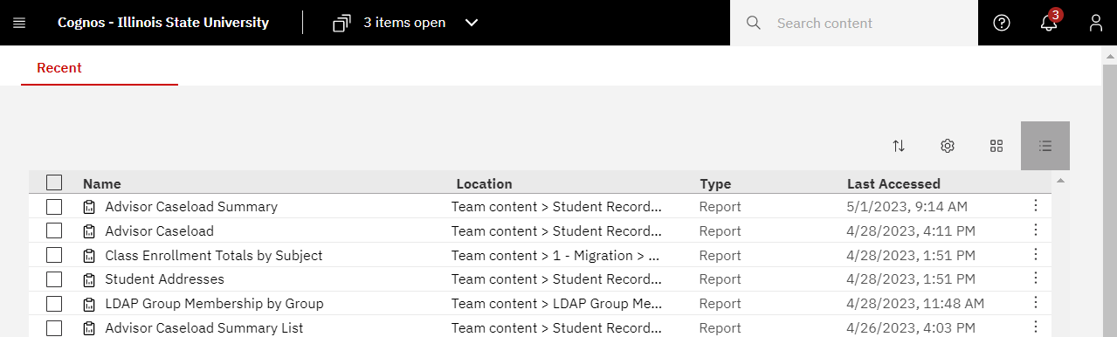

1. The user ***may*** get a popup page like the one shown below on top of the Home page. If so, do the following:
   1. Click on the X in the upper right-hand corner to close it. A Turn off welcome banner popup box is displayed.

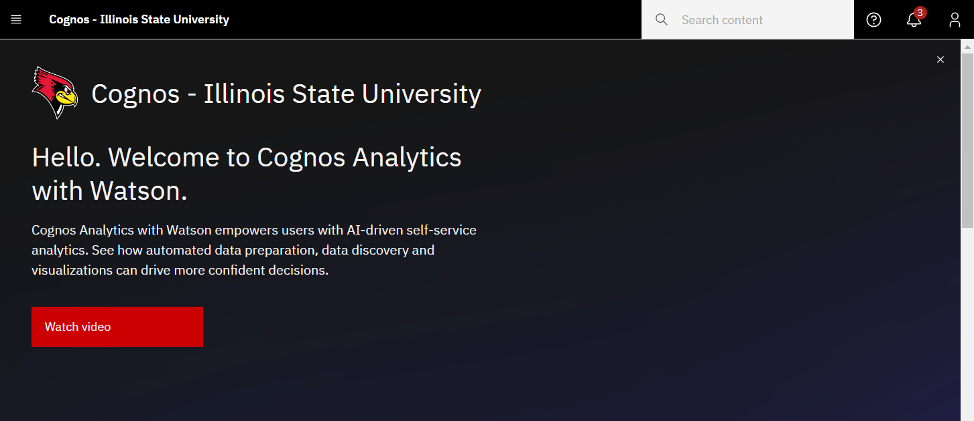

* 1. Click the OK button.

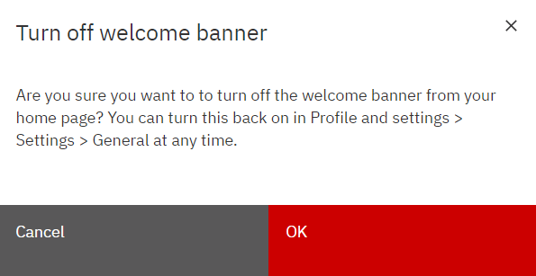

# Log out of Cognos

1. Click the  Personal Menu icon in the upper right-hand corner on the black application bar. A right sidebar is displayed.
2. Click Logout.

# Cognos Application Bar Overview

The black bar displayed at the top of the screen when logging into Cognos is the Cognos application bar. The table below describes its functions when on the Home page.

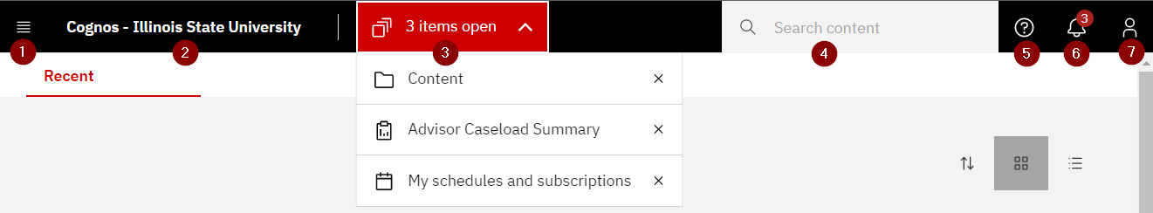

|  |  |  |
| --- | --- | --- |
| # | Icon | Description |
| 1 |  | **Open Menu:** Click this icon to open a left sidebar to display navigation actions the user can take. See the Navigation Bar Overview section for details on the actions. Click off the sidebar to close it. |
| 2 |  | **Home:** Click on the Cognos – Illinois State University text to go to the Home page. |
| 3 | (Example) | **Items Open:** This shows how many items are open in Cognos. The dropdown allows the user to click on the name of one of the items to go to that item’s page. Clicking the X to the right of an item, closes it in Cognos. |
| 4 |  | **Search Content:** Enter the Name or partial name of an item, such as a report, to be found in Cognos. Cognos will display matches in a dropdown as text is typed. If one of the options displayed match what is being searched for, click on it. Otherwise, press the Enter key when done typing and Cognos will search on it. Note that on the Results page it will show Search Results with either All Content, Team Content or My Content underlined. Cognos will display ***up to 50*** results that match. The user can also enter the name of a column on a report and ***up to 50*** reports that have a column with that name will be displayed. Save a frequent search by clicking the Save Search button under Search Content. Next time when searching, when clicking in the Search Content box, a dropdown will display saved searches. If that is the item desired, click on it. To delete a saved search, click the X to the right of the saved search. See Find a Report procedure for more details. |
| 5 |  | **Learn:** Click this icon to open the right sidebar with a search box to enter key words on a Cognos feature the user wants to know more about. This is mainly for advanced Cognos users and won’t answer basic Cognos questions. Click off the sidebar to close it. |
| 6 |  | **Notifications:** Click the Notifications icon to open the right sidebar to display existing notifications such as when a report with a subscription was executed. A number is displayed on the icon if the user has existing notifications that have not been deleted. Hover to the right of a notification and the Delete icon  is displayed. Click on it to delete the notification. The notification number on the icon will be reduced accordingly. Click off the sidebar to close it. |
| 7 |  | **Personal Menu:** Click on this icon to open a right sidebar to display multiple options regarding the user’s settings and customizations. See below for more details. Click off the sidebar to close it. |

* Personal Menu:

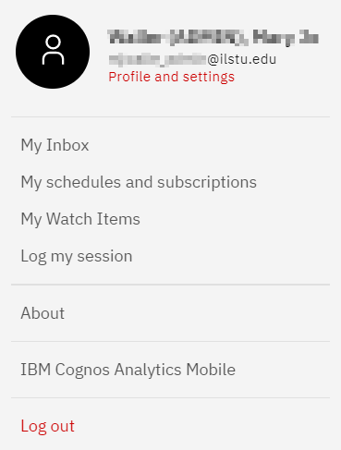

* **Profile and settings (under the user’s name and email address):** Click on this option to open a right sidebar displaying the user’s Profile and Settings.
  + Click on Profile to see profile information for the logged in user. None of the options should be changed by a typical user.
  + Click on Settings to see setting information for the logged in user. None of the options should be changed by a typical user.
* **My Inbox:** Click on this option and a new tab in the web browser is opened titled My Inbox. The page displays with any emails generated by Cognos. The most common emails displayed are those created when a user has created a subscription to run a report and email it to themselves at a specific day and time. Close the My Inbox tab in the web browser to go back to the previous Cognos screen.
* **My Schedules and subscriptions:** Click on this option to see current schedules and subscriptions. See the Definitions section above for an explanation of schedules and subscriptions and the My Schedules and Subscriptions Overview section for more details about this page. To close out of this page, click on the Items Open icon (center of the black application bar) and click the X to the right of My Schedules and subscriptions text. No schedules or subscriptions can be created in this screen. See the Create a Subscription procedure for details on creating a subscription.
* **My Watch Items:** Generally, not used. Click on this option and a new tab in the web browser is opened titled My Watch Items. If the user has notifications that have not been deleted, they will be displayed here. Close the My Watch Items tab in the web browser to go back to the previous Cognos screen.
* **Log my session:** Generally, this function is not used. Click on this option to open a right sidebar that allows the user to turn on Session Logging. This should not be done unless directed by a Cognos administrator.
* **About:** Click on this option to see the current version of Cognos. Click the Close button to close the popup box.
* **IBM Cognos Analytics Mobile:** Click on this option to find out more about the mobile app. This is outside the scope of this document.
* **Log Out:** Click this option to logout of Cognos.

# Home Page Overview

After logging in, users will land on the Home Page. The table below explains the functions on the Home page.

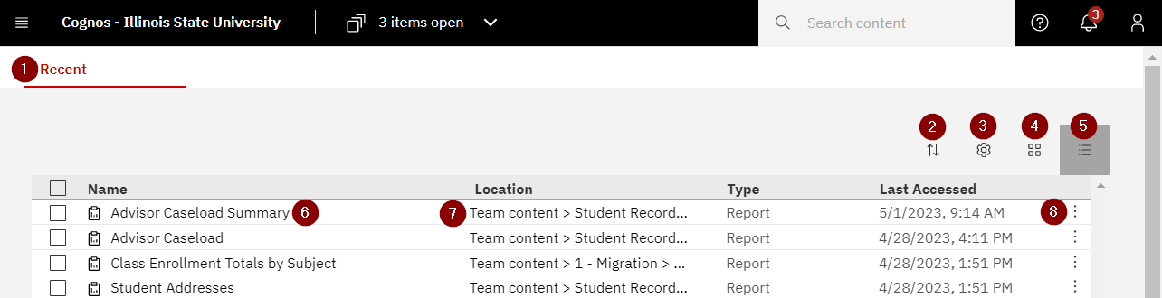

|  |  |  |
| --- | --- | --- |
| # | Icon | Description |
| 1 |  | **Home page**: This page shows the most recent 20 items the user has opened. The item’s name, location, type and last accessed is listed in list view. Tile view (see below) will not display Location. |
| 2 |  | **Reset sort:** Click on the icon and select to sort by name, modified (date/time) or by type (report/dashboard, etc.) and click on ascending or descending order. The items displayed will be sorted accordingly. |
| 3 |  | **Row Size:** (This option is only available in list view.) Select one of three options. The default option has the tallest row height with the most white space between rows. The compact option has the least amount of white space between rows. The short option row height is in between the default and compact options. |
| 4 |  | **Tile View:** Click this icon to switch to tile view. Items will display tiles across and down the screen. This view does not display the item’s location and the  Action Menu icon (three vertical dots) is only displayed when the mouse hovers over a tile. If the tile icon background is dark, it is the current view displayed. |
| 5 |  | **List View:** Click on this icon to switch to list view. Items are displayed in 20 rows. If the icon background is dark, as shown on the left, it is the current view displayed. |
| 6 | (Example) | **Name:** The name of the item such as a report title that has been viewed recently. The icon to the left of the name displays the type of item. (The type of item is also displayed in the type column.) Clicking on the name of a report will run the report in HTML (web page) format. |
| 7 | (Example) | **Location:** Displays the file path to where the item is stored in Cognos. (Breadcrumbs) |
| 8 |  | **Action Menu:** Click this icon to see a dropdown of the actions a user can take for the item in the row or tile. See below for more details. |

* In list view, checking the checkbox in front of one or more items in the list will display a red task bar above the table. In tile view, clicking on a tile, but not on the item name in the tile, will display a red task bar above the grouping. The options displayed can change depending on if one or more than one item is selected at a time and the type of item selected.

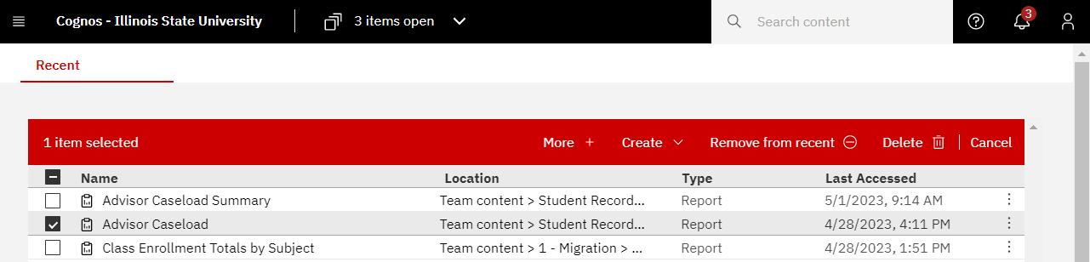

* **More + or ** Either clicking the More + on the red bar or the Action Menu icon  at the end of the row or the upper right-hand corner of a highlighted tile, will display a list of actions similar to the screenshot below. Sometimes not all the options below are displayed. It varies as appropriate for the type of item and a user’s access.

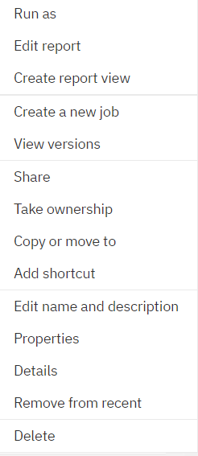

* + **Run as:** Allows a user to run the selected report in HTML (default), PDF, Excel, Excel Data, CSV or XML format. Excel format will export the report with all the images, color, and extra formatting displayed in HTML format. Excel Data format will only export the list data with no extra formatting, images or color. See the Definitions section for more detail on the Excel formats. After selecting a format, click the Run button to run the report.
  + **View versions:** This option will open a right sidebar and display the previous times the report has been run on a subscription (report the user has scheduled to run). The user can click on a version date and select to delete the version data or click on a format to display the report in that format.
  + **Share:** We don’t use this option.
  + **Properties:** This option will show the report’s properties such as the name, purpose, if it has a schedule, etc.
  + **Details:** Opens a right-hand side bar that displays when the report was created, last modified, who is the owner, etc. It also has buttons the user can click to Open (run the report in HTML), Run As (choose a display format and run the report), edit (the report) or create (a report view or job). It is not recommended to use these buttons.
  + **Remove from recent:** Takes the selected item, such as a report, and removes it off the recent list on the Home page.
  + **Edit report, Create a report view, Create a new job, Take ownership, Copy or move to, Add shortcut, Edit name or description, Delete:** Only used by Cognos administrators or others with access to create or edit a report.
* **Create, Delete:** Only used by Cognos administrators.
* **Remove from recent:** Takes the selected item, such as a report, and removes it off the recent list on the Home page.
* **Cancel:** Click Cancel to unclick the checkbox in front of the report name in list view or the checkbox in the upper right-hand corner of a tile in tile view.

# My Schedules and Subscriptions Page Overview

In Cognos,Cognos administrators can create a schedule which will run a report on a specific day and time and optionally be emailed to others. A subscription is when a Cognos user schedules a report to run and optionally be emailed to themselves. This page displays a user’s current schedules and subscriptions. While the user can edit or delete existing subscriptions from this page, a user cannot create a schedule or a subscription here.

For more details about schedules and subscriptions, see the Definitions section. See the Create, Edit or Delete a Subscription procedures for information on what you can do with subscriptions. Datasets or jobs can be scheduled and displayed on this page but are out of scope of this document.

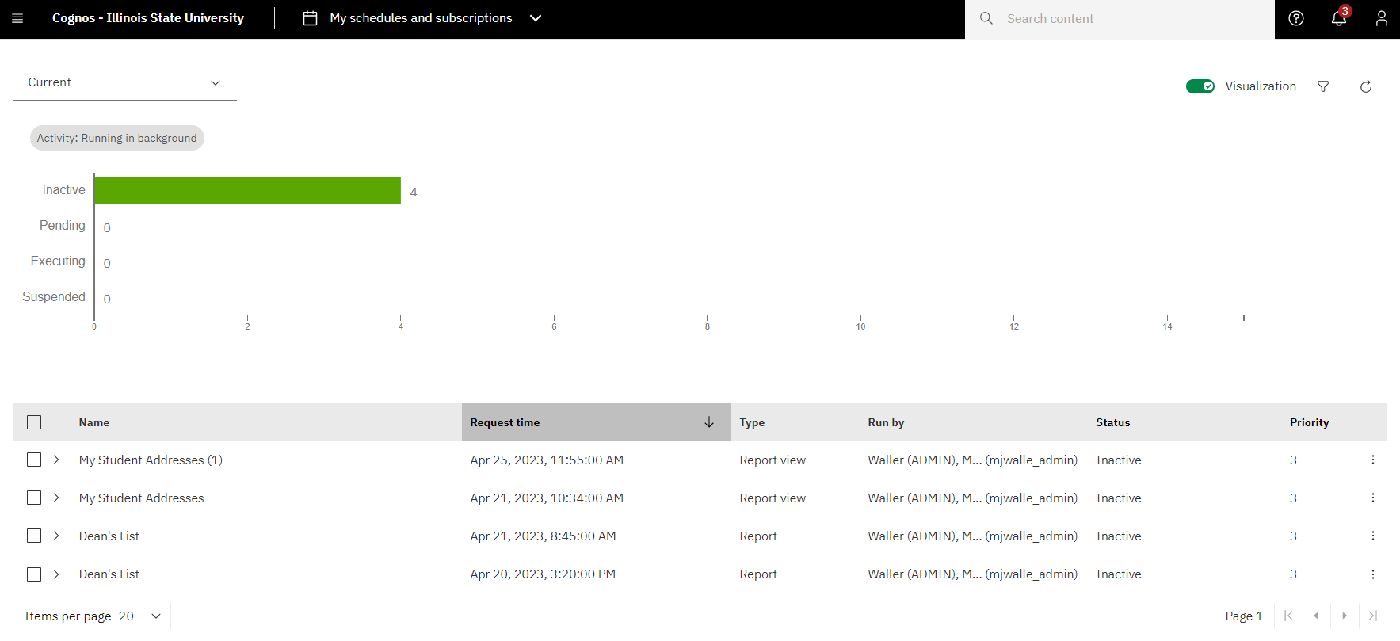

* The My schedules and subscriptions page is displayed when clicking on the  Personal Menu icon on the top right of the black application bar and selecting the My schedules and subscription option. It will open the page in Current view shown above.
* There are four views of schedules and subscriptions.

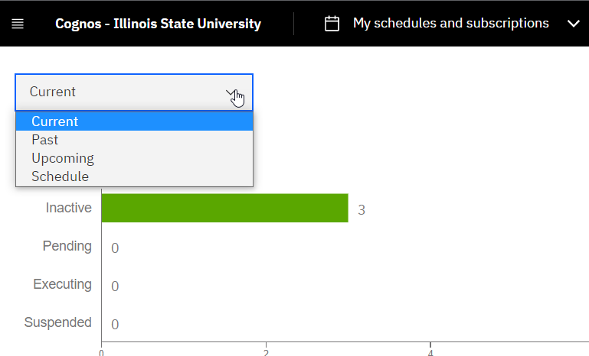

* **Current View:** This view shows any reports that the user scheduled or subscribed that are currently running.
* **Past View:** This view shows any reports that the user scheduled or subscribed that finished running in the last four hours.
* **Upcoming View:** This view shows any reports that the user scheduled or subscribed to run sometime today but have not run yet.
* **Schedule View:** This view shows any subscriptions or scheduled reports that the user created. The status field will tell the user if the report is currently active (enabled) or not active (disabled).
* More Action Menu: At the end of each row are three vertical dots which, when hovered over, display the More Actions Menu. When the user clicks on it, a dropdown with options is displayed.



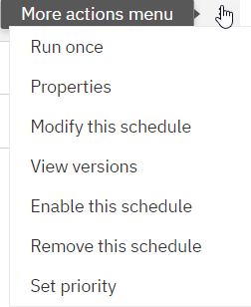

* **Run once:** This option will run the report immediately.
* **Properties:** This option will show the report’s properties such has the name, purpose, if it has a schedule, etc.
* **Modify this schedule** (or subscription)**:** This is where a user can modify a schedule or a subscription. This option is also useful when the user wants to review a subscription’s or schedule’s runtime, formats, prompts etc.

Once selected, a right sidebar will display a summary of the subscription or schedule. At the bottom, click the Show details link to see prompt values. Another option is to click the Edit link at the top right of the sidebar, and scroll through each tab (Schedule, Options, & Prompts) to see when the report it is scheduled and what prompts are used. Click the Cancel button on the bottom right when done. If the user wants to make changes to the subscription, see the Edit a Subscription procedure for more details.

The user should look here before deleting a schedule or subscription to be sure they are deleting the one they want. (Note that only the word “schedule” is named in the dropdown, but this option refers to schedules and subscriptions.)

* **View versions:** This option will open a right sidebar and display the previous times the report has been run. The user can click on a date and select to delete the version data or click on a format to display the report in that format.
* **Enable/Disable this schedule** (or subscription)**:** This option will display Enable if the schedule or subscription has been disabled or it will display Disable if the schedule or subscription is enabled. It allows the user to activate or deactivate a schedule or subscription. (Note that only the word “schedule” is named in the dropdown, but this option refers to schedules and subscriptions.)
* **Remove this schedule** (or subscription):This option allows the user to permanently delete a schedule or subscription. (Note that only the word “schedule” is named in the dropdown, but this option refers to schedules and subscriptions.)
* **Set Priority:** This option allows the user to select a run priority from 1 to 5. Priority 1 runs before priority 5. The default is 3. This is normally not changed.
* Any item that starts with “My” is a subscription. Cognos adds “My” to the front of a report name to distinguish it from a schedule.
* A schedule or subscription can be listed more than one time with (1), (2), (3), etc. at the end of the report name. This can be for multiple reasons.
  + The user can create a subscription to run the same report, with the same prompts, multiple times a day. Each new subscription will get a number at the end of its name after the first subscription for the report is created.
  + The user can create a subscription to run for the same report, with different prompts. Each new subscription will get a number at the end of its name after the first subscription is created.
* To tell the difference between a subscription that has (1), (2), or (3), etc. after the name, the user needs to click on the  More Actions Menu icon and select Modify this schedule. Then review the summary in the right sidebar and click Show details at the bottom to see prompt information.

# Open Menu Overview

* The Open Menu icon in the upper left-hand corner in the black application bar is the main navigation tool in Cognos. Click on it to open a left sidebar with navigation options. The user may not see all these options based on the user’s permissions.

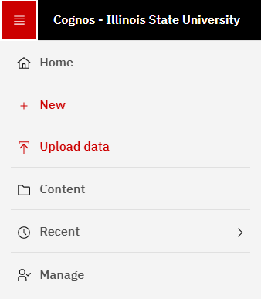

* **Home:** Click this option to go to the Home page that shows the user’s most recently opened reports.
* **New:** Only used by Cognos administrators or others with access to create something new, such as a report, in Cognos.
* **Upload Data:** Only used by Cognos administrators to quickly upload files to Cognos.
* **Content:** Click on this option to go to the Content page where all Cognos items, such as reports, are stored.
* **Recent:** Click on this option to show the top 20 most recent items accessed in Cognos.This is more of a short-cut which can be used instead of clicking on the Home page which shows the same data.
* **Manage:** Only used by Cognos administrators to maintain and manage Cognos.

# Navigating Cognos

This procedure explains how to get to the most commonly used pages in Cognos.

1. Home Page (Recent Reports)
   1. Click on the  Open Menu icon in the upper left-hand corner on the black application bar. A left sidebar is displayed.
   2. Click .
2. Recent Report
   1. Click on the  Open Menu icon in the upper left-hand corner on the black application bar. A left sidebar is displayed.
   2. Click .
   3. Scroll the list of recent reports to find the report.
3. Content Page
   1. Click on the  Open Menu icon in the upper left-hand corner on the black application bar. A left sidebar is displayed.
   2. Click .
   3. When the Content page displays, select Team Content unless the user wants to see reports that they created. In that case, click on My content.
4. Student Records Report (or other types of reports)
   1. Click on the  Open Menu icon in the upper left-hand corner on the black application bar. A left sidebar is displayed.
   2. Click .
   3. When the Content page displays, select Team Content.
   4. In the table find the package folder for the category of the report to be viewed. For example, Student Records or Admissions. The user may have to scroll to find the package folder they are looking for. Click on the folder.
   5. Click on the Reports folder. All the reports for that category are displayed. Sometimes there are additional folders such as restricted or self-service. The user can click on those if they don’t find what they want in the main Reports folder. See Find a Report procedure for another way to find a report.
5. The User’s Custom Report
   1. Click on the  Open Menu icon in the upper left-hand corner on the black application bar. A left sidebar is displayed.
   2. Click .
   3. When the Content page displays, select My Content.
   4. In the table find the report to be viewed. If the user has added additional folders for navigating their reports, click on those until the report is found. The user may have to scroll to find the folder or report they want. See Find a Report procedure for another way to find a report.
6. My schedules and subscriptions Page
   1. Click on the  Personal Menu icon in the upper right-hand corner on the black application bar. A right sidebar is displayed.
   2. Click on My schedules and subscriptions. It will open the page in Current view.
      1. Current View shows any reports that the user scheduled or subscribed that are currently running.
      2. **Past View:** This view shows any reports that the user scheduled or subscribed that finished running in the last four hours.
      3. **Upcoming View:** This view shows any reports that the user scheduled or subscribed to run sometime today but have not run yet.
      4. **Schedule View:** This view shows any subscriptions or scheduled reports that the user created. The status field will display if the report is currently active (enabled) or not active (disabled).
   3. To see all subscriptions and schedules created by the user, in the upper left-hand corner next to Current, click the down arrow and select Schedule. This will show all their existing subscriptions and schedules whether they are enabled or disabled. It will not show deleted ones.

# Find/Search for a Report

Cognos search feature can be used to search for a report by its name or by the name of a column in the report. The user can just provide a partial name, but the more complete the better the results. It does have some limitations. It will only show the first 50 results.

1. In the black application bar at the top of the page, find the Search Content box.



1. Click in the Search content box. If the user has saved searches, they will display in a dropdown. If one of the saved searches is desired, click on the item and it will go to the Results page. (If selecting a saved search, skip some steps below until the Results page screenshot.)
2. Enter the full or partial name of the report in the box. If the report name is not known, but one of its column names is known, it can be entered instead. Cognos will accept partial words or report names, but the more complete the search, the more accurate the search results.
3. When typing in a name, Cognos will begin to display search results under the box. Click on a search result in the dropdown if it matches what the user intends to type. It will populate the search box with the item selected.
4. If no item in the dropdown matches the typed entry, when done typing search words, click the Enter key on the keyboard and the Results page will display.

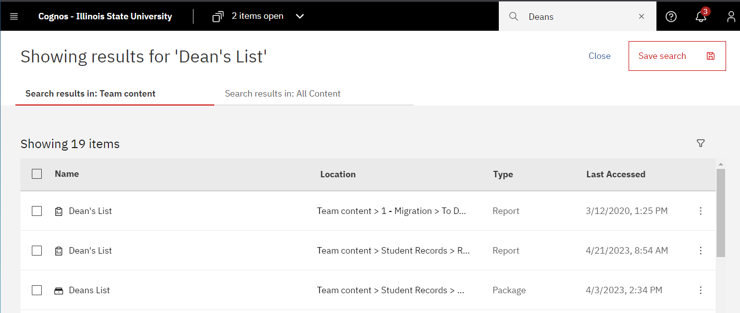

1. On the results page, under the header, note the search source is underlined. Other possible sources may be listed but are NOT underlined on the row. If the search source desired is not underlined, click on the search source desired, and the Results page will update using the selected source.
   1. **All Content:** Searches in Team Content and My Content for results.
   2. **Team Content:** Searches just in Team Content for results. See the Definitions section for more information about Team Content.
   3. **My Content:** Searches just in My Content for results. See the Definitions section for more information about My Content.
2. There may be multiple versions of the same report (same name). See the screenshot above as an example. It is important to look at the type and location to determine the item desired.
   1. **Type:** This displays the type of item on the row such as Report, Package, Data Set, etc. When looking for a report, look only for Type = Report.
   2. **Location**: This will display the path of the item. If the full path is not displayed, hover over the path and it will display.
      1. For a report that other users have access to, confirm the file path starts with Team Content.
      2. Also, do not select any report in a “1 – Migration” folder. That is a temporary location.
   3. Look for the package folder and then the Reports folder. In the example above, see the second item where Type = Report and path = Team Content > Student Records > Reports is the item to select.
3. If searching for something very common, such as a common header name in multiple reports, the item the user wants may not be displayed. This is because Cognos only shows the first 50 matches. Try a more specific name or search source to reduce the number of results.
4. The Results page behaves just like the Home page. See the Home Page Overview for options of what can be done on the Results page.
5. If the user will want to search on that item again, they can click on the Save Search box to save that search. The next time the user searches on this item, when the cursor is clicked in the Search Content box, a dropdown will display with all saved searches.

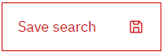

1. To delete a saved search, enter the cursor in the Search Content box, and click the X to the right of the saved search to delete it.

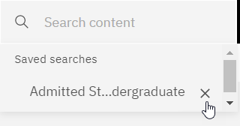

# View a Recent Report

1. If not already on the Home page, Click on the  Open Menu icon in the upper left-hand corner on the black application bar and click . The Recents table will be displayed.
2. Find the report by scrolling down if needed. If the report is not displayed, follow the View a Report procedure.
3. To run the report in a web page, which is the default, click on the name of the report.
4. To run the report in a format other than a web page (HTML format), do the following:
   1. If in row view, click on the  Action Menu icon at the end of the row and select Run As from the dropdown.
   2. If in tile view, click in the upper right-hand corner of the tile and the  Action Menu icon will display. Select Run As from the dropdown.
   3. Select the format, such as Excel or Excel data format. See the Definitions section for more information about these formats.
5. If the report has prompts, a prompt page is displayed. Enter the prompts to filter the report. Do this for all prompt pages.
6. A spinning circle will display while the report processes. Be patient.
7. If selecting to display the report on a web page, the report will display when it is completed.
8. If selecting to display the report in another format, when the report is done, it will display “Downloading this report in X format” where X is the format that was selected. It will download the report to a file at the bottom left of the screen. Double-click on the report to open it.
9. To see the report with different filters, click the  Run icon at the top left of the report and enter the prompts to filter the report. Do this for all prompt pages.
10. See the Report Page Overview for options that can be performed if the HTML format was selected.

## Troubleshooting

There are times when the error message below may display when trying to run a report. This can happen for a couple of reasons.

1. If the user has not been active in the Cognos application for a while, the system will automatically log the user out. In that case, the user no longer has access to the report they are trying to run.
2. Occasionally, a newer version of the report replaces the existing report. When this happens, the old link in the recent page will not be able to find the old version of the report.

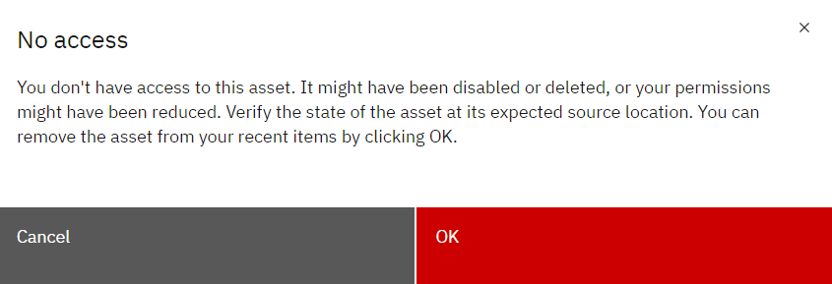

1. Click the OK button to close the error message.
2. On the web browser, click the refresh icon (arrow going in a circle on the upper left.)
3. If the user has been logged out of Cognos, and it has not been a long time, Cognos will automatically log the user back in without the user having to re-enter their username and password.
4. If the user has been logged out of Cognos for a while, the Central Login page will be displayed. The user will need to re-enter their username and password and click the Log In button to get back into Cognos.
5. Try to click on the report name again to see if the report will run without getting the above error message.
6. If still getting the error message, click OK to close the message and follow the View a Report procedure. It will direct the user to the Content page and have them follow the file path to the report.
7. If still having trouble, follow the Log Out procedure and the Log In procedure and try to run the report again.
8. If still receiving the no access error message from the Content page, send an email to the Technology Support Center at [supportcenter@ilstu.edu](mailto:supportcenter@ilstu.edu). In the email provide the file path of the report and what was tried to get the report to run. Someone from Enterprise Data & Analytics will respond.

# View a Report

1. Click on the  Open Menu icon in the upper left-hand corner on the black application bar and click .
2. To select a report created by the Enterprise Data & Analytics team created for multiple users, click on Team Content if it is not already underlined.
3. To select a report the user created, click on My Content if it is not already underlined.
4. Click on folders to navigate through the file hierarchy to get to the report desired. It may be necessary to scroll to find the folder or report. For Team Content reports, select the package name such as Student Records or Admissions, and then click Reports. Most reports for this package are displayed in this folder. Occasionally there will be additional folders in the Reports folder that lead to more reports such as Restricted or Self-Service. Explore these folders to find the report if the report is not in the main Reports folder. See the Find/Search for a Report procedure if the report cannot be found.
5. To run the report in a web page, which is the default, click on the name of the report.
6. To run the report in a format other than a web page (HTML format), do the following:
   1. If in row view, click on the  Action Menu icon at the end of the row and select Run As from the dropdown.
   2. If in tile view, click in the upper right-hand corner of the tile and the  Action Menu icon will display. Select Run As from the dropdown.
   3. Select the format, such as Excel or Excel data format. See the Definitions section for more information about these formats.
7. If the report has prompts, a prompt page is displayed. Enter the prompts to filter the report. Do this for all prompt pages.
8. A spinning circle will display while the report processes. Be patient.
9. If displaying the report on a web page, the report will display when it is completed.
10. If the report has links in it, the user can click on a link, and it will drill down on that cell and provide more details. Only some reports are designed this way.

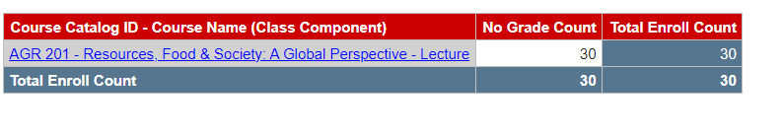

1. If displaying the report in another format, when the report is done, it will display “Downloading this report in X format” where X is the format selected. it will download the report to a file at the bottom left of the screen. Double-click on the report to open it.
2. To see the report with different filters, click the  Run icon at the top left of the report and enter the prompts to filter the report. Do this for all prompt pages.
3. If displaying the report in the default HTML format, see the Modify an Interactive Report procedure to learn how to make changes to an open report.
4. If a no access error message is displayed, as shown in the View a Recent Report procedure, and the report will not run, follow the Troubleshooting section there.

# Export a Report

This procedure explains how to export a report that has been opened and export a report that has not yet been opened. It also explains the export options available to the user.

1. **If a report has not been opened,** 
   1. Navigate to the report to be exported. See the Navigating Cognos or the View a Report procedures for details.
   2. If in row view, click on the  Action Menu icon at the end of the row and select Run As from the dropdown.
   3. If in tile view, click in the upper right-hand corner of the tile and the  Action Menu icon will display. Select Run As from the dropdown.
   4. Select the report format, such as Excel or Excel data format. See below for detail about all format options.
   5. If the report has prompts, a prompt page is displayed. Enter the prompts to filter the report. Do this for all prompt pages.
   6. A spinning circle will display while the report processes. Be patient.
   7. When the report is done, it will display “Downloading this report in X format” where X is the format selected. it will download the report to a file at the bottom left of the screen. Double-click on the report to open it.
2. **If a report is open,**
   1. If the report displayed does not have the filters desired, for example it displays undergraduate data, but graduate data is desired, re-run the report with the desired filters. See View a Report procedure.
   2. Click the down arrow next to the triangle on the edit toolbar in the upper left-hand corner of the screen. Don’t click the triangle!
   3. Select the report format, such as Excel or Excel data format. See below for detail about all format options.
   4. A spinning circle will display while the report processes. Be patient.
   5. When the report is done, it will display “Downloading this report in X format” where X is the format selected. it will download the report to a file at the bottom left of the screen. Double-click on the report to open it.

* **Report Format Options**
  1. **HTML:** This is the default format and will display the report on a web page.
  2. **PDF:** This format will export the report in PDF format which will create a static view of the report with all formatting intact.It may have to display a row on multiple pages depending on the width of the report. For that reason, many of ISU’s reports do not display well in PDF format.
  3. **Excel:** This format will export the report as an .xlsx document with all the images, color, and extra formatting displayed such as in the HTML format (web page). Sometimes a report must be exported in Excel format instead of Excel data format so all the report data will display due to how the report was designed. The column widths of these reports sometimes are too wide and may need to be adjusted after the report is opened in Excel.
  4. **Excel data:** This format will export the report as an .xlsx document with only the tabular data. It will have no extra formatting, images, color, or prompt data that may be on the HTML format (web page) or the Excel format. If the report has any totals or count summaries at the bottom of the report, they are displayed at the end of the columns, each in its own column. Any additional header information other than column names are not exported. If the report is designed to group multiple fields in one cell, this format will put each field in its own column.
  5. **CSV:** This format will export the report in a .csv (comma separated value) document with only tabular data. This is most commonly selected when using a program other than Excel. It will have no extra formatting, images, color, or prompt data that may be on the HTML format (web page) or the Excel format. Each row in the report is a row in the output with each column separated by a comma. The first row has all the header titles comma separated. Any additional header information other than column names are not exported.
  6. **XML:** This format will export the report as an .xml document.

# Report Page Overview

The Report page below displays features for interactive reports. If a report is not interactive, the user will not see the Undo and Redo icons. Those features and others like sorting and filtering are not available for standard reports. Most of ISU’s reports are interactive. For more information about interacting with or modifying a report, see the Modify an Interactive Report procedure.

See the Cognos Application Bar Overview for details on the black application bar. The only one mentioned below is related to the specific opened report.

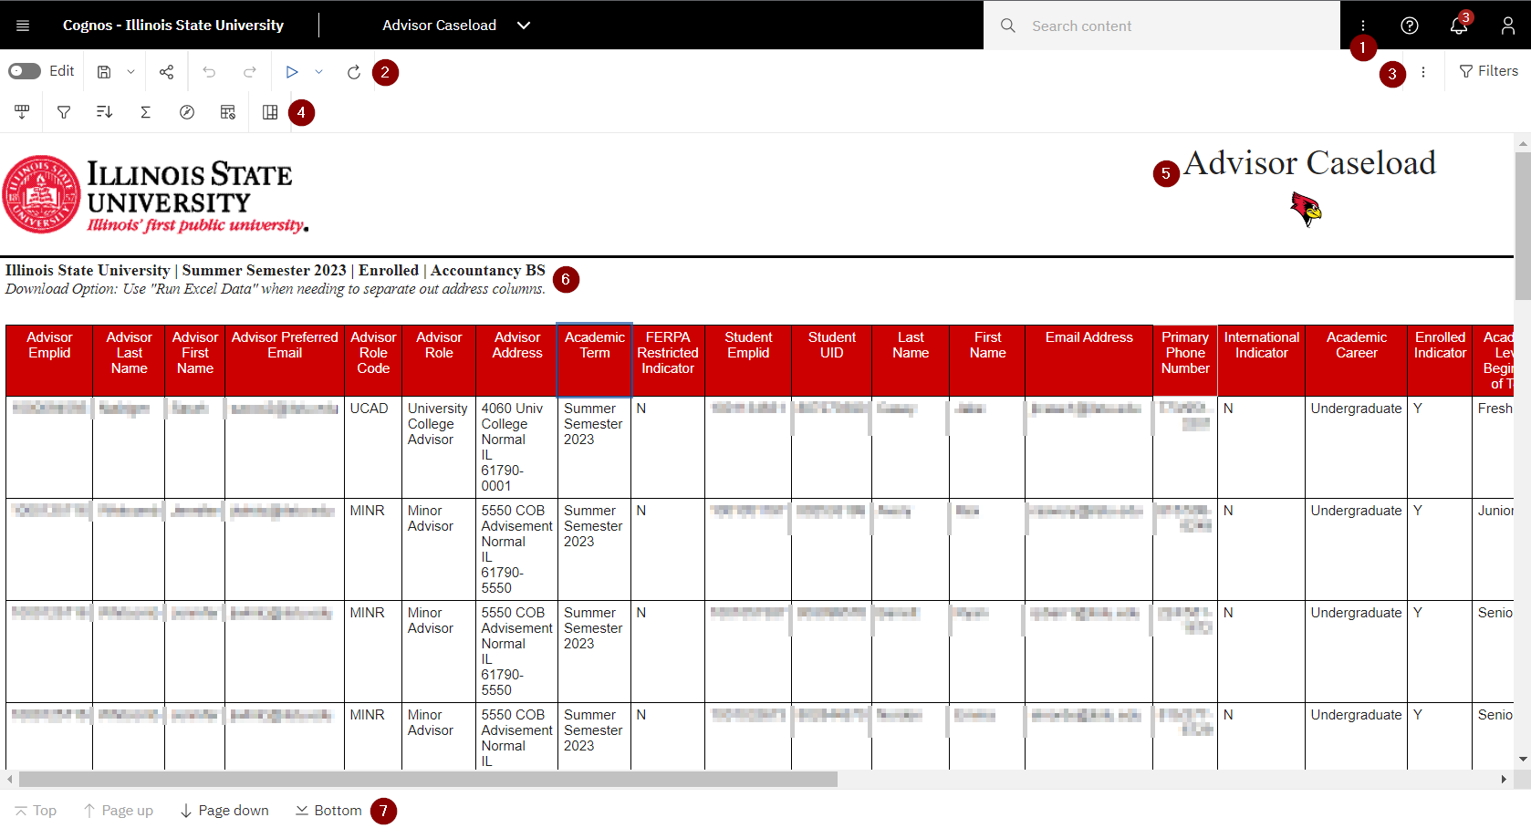

|  |  |  |  |
| --- | --- | --- | --- |
| # | Icon | Description | |
| 1 |  | **More:** Click on this and the Subscribe option will display. Click on Subscribe to schedule the report to run weekly using the prompts in the report. See the Create a Subscription procedure for more details. Note this More icon has different options then the More icon at the top of the report and below the black application bar. | |
| 2 |  | **Edit Toggle Switch:** Swipe right to turn on edit mode and swipe left to turn off edit mode. The icon on the left is shown in off mode. If swiped to the right, the icon would turn green and a few more options would display on the edit toolbar to the right. | |
| 2 |  | **Save** and **Save as**: Click on the disk icon to save the report. Click the arrow down to save copy of the report with a new name and location. Only some users have access to save a report in Cognos. | |
| 2 |  | **Share:** Not recommended to share or embed report output. | |
| 2 |  | **Undo** or **Redo**: Click the arrow pointing left to reverse (undo) the last action. Click the arrow pointing right to do the last action that was just reversed (redo). | |
| 2 |  | **Run** or **Run as**: Click the triangle to run the report in HTML (web page) format and if the report has prompts, they will be displayed for the user to select. Click the down arrow next to the triangle to run the current report with the same prompts as the report displayed. Select a format to display the report (Excel, Excel Data, etc.) from the dropdown. | |
| 2 |  | **Refresh:** Click refresh to redisplay the page. The user may want to do this if it has been a while since they have performed any action in Cognos so they can log back in again. | |
| 3 |  | **More:** Click on the More icon to display a dropdown that changes based on other actions executed on the page. Normally not used much. Note this has different options than the More button on the black application bar. | |
| 3 |  | **Filters:** Click on it to open a right sidebar that allows the user to see any filters that were interactively added after the report was generated. A filter can be removed by clicking on the  Delete icon. The report may not update right away. If the screen goes blank, the user will have to click the  Run icon and re-select any prompts to see the updated report with the filter(s) removed. Click on the filter icon to close the sidebar. The user cannot add a filter using this icon. Use the filter icon on the interactive toolbar, next to the Sort icon, to add a filter. See the Modify an Interactive Report procedure for more details. | |
| 4 |  | **Dock or Undock Interactive Toolbar:** The toolbar is normally docked in the upper left-hand corner above the report under the Edit icon. If it is not there, it can be on or above a column header. Sometimes it is not on the screen at all. If the toolbar cannot be found, click on a field in the report and it will display above the field. | |
| 4 |  | **Filter** (next to the Sort icon): Allows the user to add one or more filters to the report. Click on the column to filter on, then click the filter icon. To include or exclude a specific value for the filter, click on that value in the report and then the filter icon and it will provide that option in the dropdown. It allows the user to create custom, more complicated filters or remove all filters. The report may not update right away. If the screen goes blank, click the  Run icon and re-select any prompts to see the updated report with the filter(s). Unless the report runs quickly and the desired filter is basic, it is recommended to export the report to Excel and use the filter in that tool. See the Modify an Interactive Report procedure for more details. | |
| 4 |  | **Sort:** Click on a column to be sorted and click the Sort icon. It will display a dropdown to select ascending, descending, or stop sorting. The report may not update right away. If the screen goes blank, click the  Run icon and re-select any prompts to see the updated report with the sorting. For more complicated sorting, such as multiple columns, select the Edit layout sorting option. Unless the report runs quickly and the desired sorting is basic, it is recommended to export the report to Excel and use the sort function in that tool. See the Modify an Interactive Report procedure for more details. | |
| 4 |  | **Summarize:** Click on a field to summarize and then click the Summarize icon. A dropdown will display allowing the user to pick Total, Count, etc. The report may not update right away. If the screen goes blank, click the  Run icon and re-select any prompts to see the updated report with the summary row(s). Scroll and/or page down to the end of the report and the last row will show the summarized value in that column. The user will have to close the report and re-run it to clear the summarized rows. See the Modify an Interactive Report procedure for more details. | |
| 4 |  | **Lineage Information:** Click on a field value and then the Linage icon to find the database source for the field. A popup box will display the field name, its namespace, and its data source. The Technical View (tab at the top) will show the field’s table name and how it is related to other tables. | |
| 4 |  | Add Calculated Members: Click on this icon to show a dropdown with options such as suppressing rows that have missing values, zero values, etc. Click on this again to remove the suppression. See the Modify an Interactive Report procedure for more details. | |
| 4 |  | Group Data: Click on a field to be grouped and then click on the group icon. The report may not update right away. If the screen goes blank, click the  Run icon and re-select any prompts to see the updated report with the grouping. Click on the group icon again to remove it. When data is grouped, repeat values in the same column next to each other are merged so the data is displayed only once across multiple rows. See the Modify an Interactive Report procedure for more details. | |
| 5 | (Example) | **Title**: The report title. | |
| 5 |  | **Reggie’s Redbird:** Click on Reggie’s Redbird icon to view a description of all the fields on the report and their filters. | |
| 6 |  | **Prompt Selections:** The selections the user made to run the report. If there are any special instructions, such as download options, they are also listed here. | |
| 7 |  | | **Page Navigation**: The bottom left of a report, may have page navigation. Click on Top, Page up, Page down or Bottom to move through the pages in the report. Not all reports have page navigation. If no page navigation exists, just scroll through the report. |

# Modify an Interactive Report

Interactive reports allow users to create their own edits to reports. If a displayed report does not show the Undo and Redo icons, it is a standard report and cannot be modified.

Most of ISU’s reports are interactive. Some users can save a modified report in their My Content folder.

While interactive reports can be modified in Cognos, only do this for simple modifications. Otherwise, it is recommended to use Excel to make report modifications.

***Standard Report View***

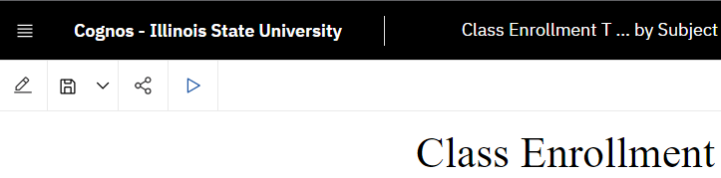

***Interactive Report View***

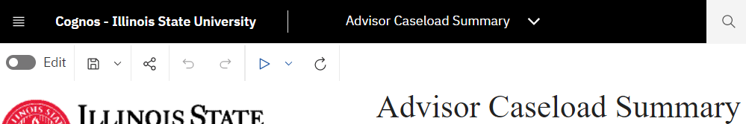

***Helpful Tips***

* Use the Undo and Redo icons in the top left corner in the Edit toolbar to modify edits.
* Use the Edit Layout Sorting menu under the Sort icon in the Edit toolbar to view and change the way the report is being grouped and sorted.
* Use the Filter icon in the top right corner to see the filters that have been added to the report.
* If you have permissions and want to view the report modifications at a later time, save the modified report to the My Content folder.
* **Interactive Filter:** Reduce the data returned in the current report.
  1. The report to be filtered has been run and is displaying in Cognos. If not, see the View a Report procedure to run a report.
  2. To confirm the displayed report is an interactive report, check that the Undo and Redo icons are displayed at the top left-hand side of the report.
  3. Click on the field whose data is to be restricted/filtered. To include or exclude a certain value, click on the field with that value. For example, for the screenshot below, the user chose to click on UCAD so they can easily filter the report including or excluding that value.
  4. The interactive toolbar may be docked or undocked. If docked, it is displayed in the upper left corner of the report. If undocked, it may not appear at all, or it appears above the selected field.
  5. Undocked:

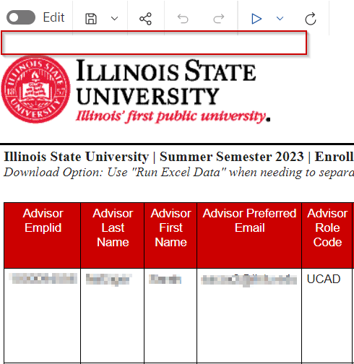

* 1. Docked:

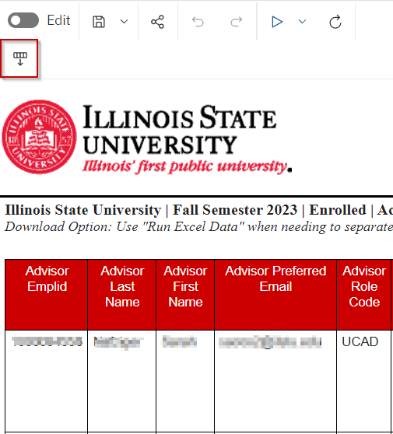 or 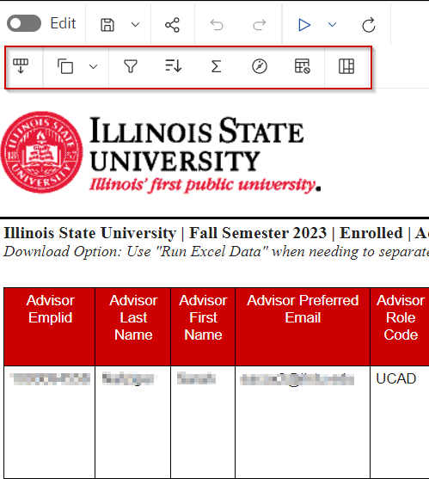

* 1. Click on the  Filter icon on the edit toolbar next to the Sort icon. A dropdown box will display with filtering options. If filtering on a numerical value, it displays number ranges such as greater than or less than the value selected.

Text field filter dropdown / Numeric field filter dropdown:

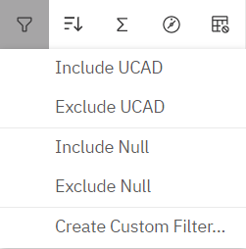 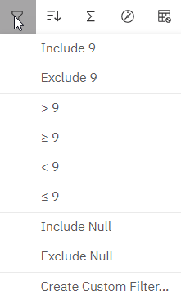

* 1. Using the originally selected field value, the dropdown will display options to include or exclude that value by clicking the option. It also displays some other options including Create Custom Filter. Use Create Custom Filter for more complicated filtering.
  2. If Create Custom Filter is selected, the Filter Condition popup box will be displayed. Only make changes in one of the tab options below and click OK.
     1. Text field Individual tab / Numeric field Individual tab:

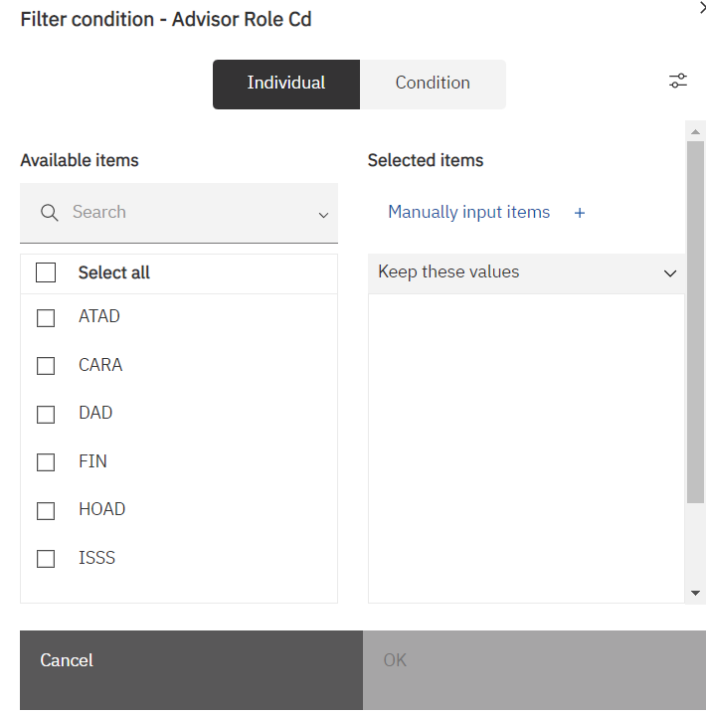 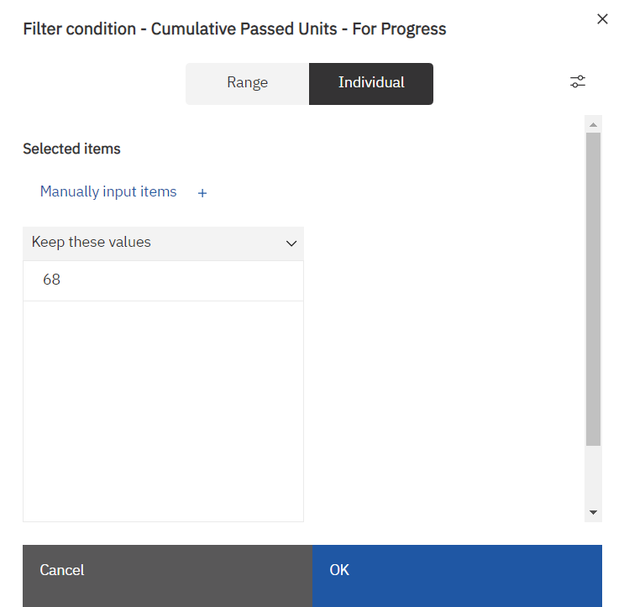

* + 1. To keep the select values, leave the Keep these values option set. Otherwise, click the down arrow to the right of Keep these values and select Exclude these values.
    2. For text values, on the left side under Available items, use the checkboxes to check items or the Search box to find items to check. Checked items will be added to the Selected items side.
    3. To manually input values, click on that link to open the Manually input items popup box.

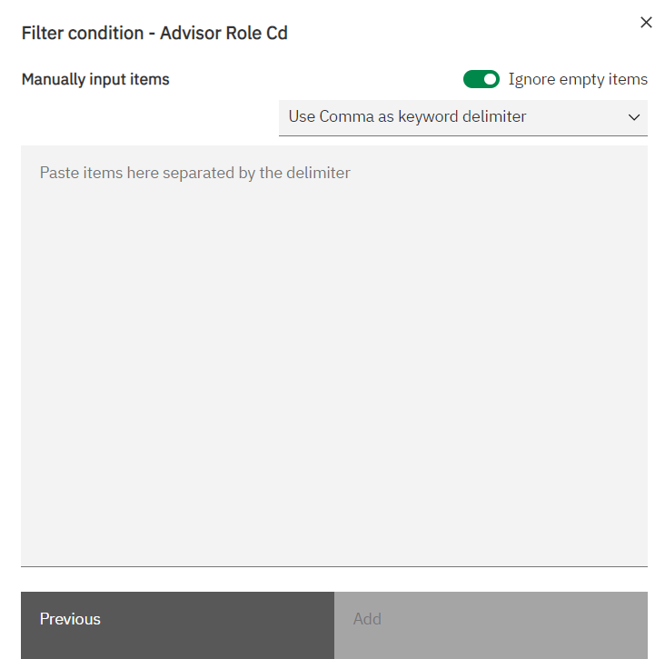

* + 1. The Use Comma as keyword delimiter option is the default. To change it, click the down arrow to the right and select another option like new line as a delimiter instead.
    2. In the Paste items here… section enter or paste the items separated by the delimiter chosen. With the comma delimiter with a numeric value “3, 4, 5” would be a valid entry.
    3. Click on the Add button to add the items to the list.
    4. It goes back to the Individual tab showing the entered items.
    5. If the Condition tab (for text fields) or Range tab (for numeric fields) is selected instead of the Individual tab:

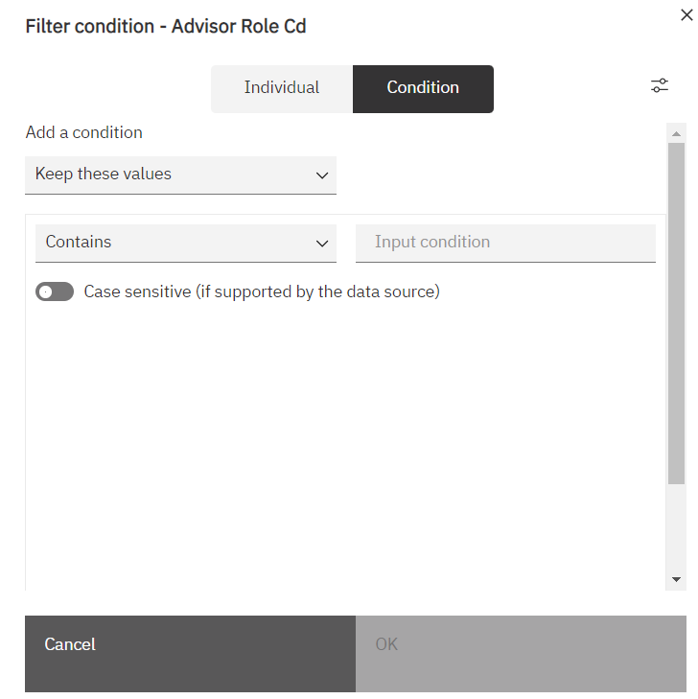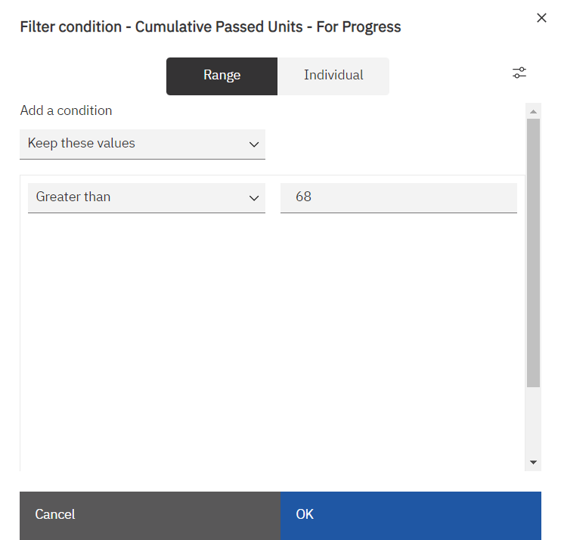

* + 1. To keep the values selected, leave the Keep these values option. Otherwise, click the down arrow to the right of Keep these values, and select Exclude these values.
    2. For text values, to enter complete values instead of partial ones (“Undergraduate” instead of “Under”), leave the Contains option. Otherwise, click on the down arrow to the right of Contains and choose either Starts with Ends with or Matches SQL pattern (not explained here).
    3. For numeric values, if using greater than as the operator, leave the Greater than option. Otherwise, click on the down arrow to the right of Greater than, and select another mathematical operator such as < or between, etc.
    4. For text values, click in the Input conditions and enter the full or partial value to filter on.
    5. For numeric values, click in the right box across from the selected operator, and enter the number or formula to filter on.
    6. Click OK to filter the report.
  1. The report may not update right away. If the screen goes blank, click the  Run icon and re-select any prompts to see the updated report with the filter(s). Unless the report runs quickly and the desired filter is basic, it is recommended to export the report to Excel and use the filter in that tool.
  2. To remove the interactive filters just created, click on the Filter icon and select the Remove all filters option.
* **Interactive Sorting:** Change the sorting of the report.
  1. The report to be sorted has been run and is displaying in Cognos. If not, see the View a Report procedure to run a report.
  2. To confirm the displayed report is an interactive report, check that the Undo and Redo icons are displayed at the top left-hand side of the report.
  3. View the current sorting that is being done on the report.
     1. If the interactive toolbar is docked, the Dock or Undock Interactive Toolbar icon is displayed at the upper left side at the top of the report.
     2. If the interactive toolbar is not docked, it may not be visible. Click on a field in the report and the toolbar will appear above it. Click the Dock or Undock Interactive Toolbar icon to dock it on the upper-left side at the top of the report.
     3. Click on the Sort icon and a dropdown is displayed. Select Edit layout sorting… and the Grouping & sorting popup box below appears.

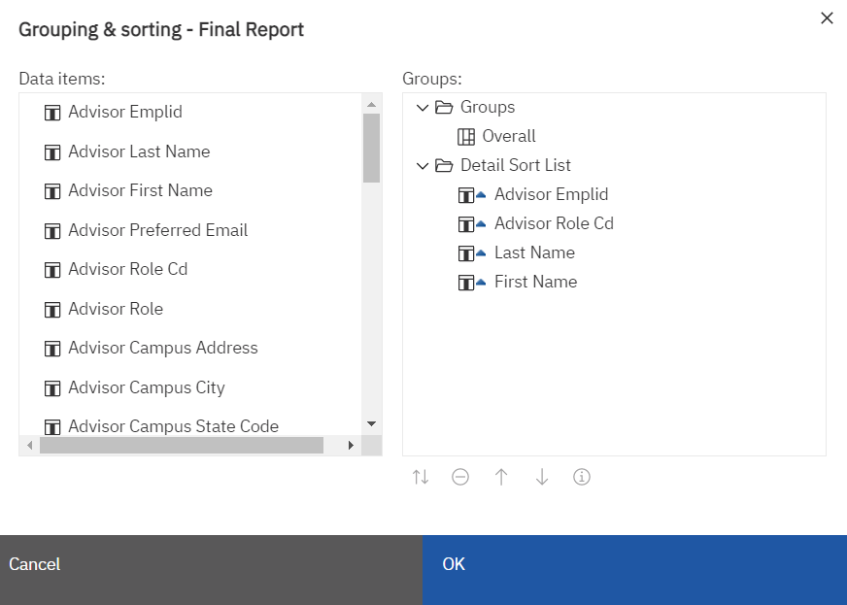

* + 1. If there are multiple Groups, expand them to see if there is any sorting in the grouping.
    2. Under Detail Sort List it will display the fields that are sorted. They are listed from top to bottom for order. If they have a triangle pointing up the order is ascending. If they have a triangle pointing down, it is in descending order. For the example above, the report is sorted by Advisor Emplid ascending, then by Advisor Role Cd ascending, then Last Name ascending, and finally by First name ascending.
  1. To sort by another column,
     1. On the right side, highlight the Detail Sort List folder by clicking on it. Very important step!
     2. On the left side, double click on the field to be sorted. It should now display at the bottom of the list at the right under Detail Sort List. If it is under the Groups folder, click the Cancel button and remember to highlight the Detail Sort List order first.
  2. To change the order of a sort field, click on the field on the right, and at the bottom use the big  up arrow or down arrow to move that field up or down in the list.
  3. To change a field to sort from ascending to descending or the reverse, click on the field and then at the bottom select the small  up and down arrows icon.
  4. To remove a field from sorting, click on the field and at the bottom and select the  Delete icon. The field will be removed from the list.
  5. Select the OK button to save the changes.
  6. The report may not update right away. If the screen goes blank, click the  Run icon and re-select any prompts to see the updated report with the sort(s). Unless the report runs quickly and the desired sorting is basic, it is recommended to export the report to Excel and use the sorting in that tool.
* **Interactive Grouping:** Change the grouping of the report. For grouping it is best to sort on the item to be grouped.
  1. The report to be grouped has been run and is displaying in Cognos. If not, see the View a Report procedure to run a report.
  2. To confirm the displayed report is an interactive report, check that the Undo and Redo icons are displayed at the top left-hand side of the report.
  3. If the interactive toolbar is docked, the Dock or Undock Interactive Toolbar icon is displayed at the upper left side at the top of the report.
  4. If the interactive toolbar is not docked, it may not be visible. Click on the field that is to be grouped and the toolbar will appear above it. Click the  Dock or Undock Interactive Toolbar icon to dock it on the upper-left side at the top of the report.
  5. Click the  Group icon. If the field being grouped is ALREADY a sorted field, the field will be moved to the top of the sort list and be added to the Groups section. This means the sort order of the report has been changed! If the field being grouped is not a sorted field, it will NOT be added to the Groups section and no sorting will be done on this field.

Before grouping on a sorted field / After grouping on a sorted field:

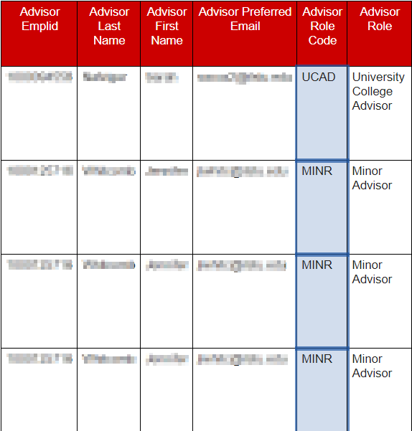 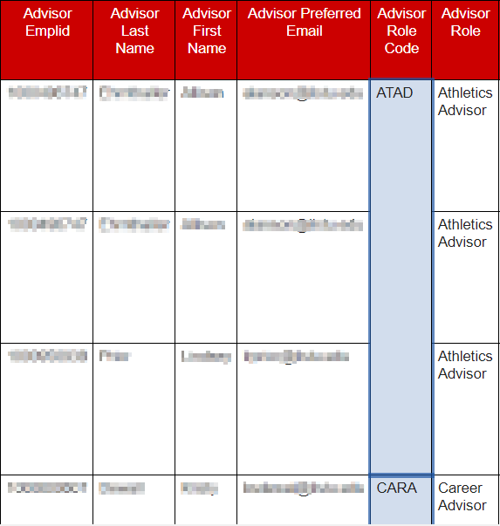

* 1. Custom Grouping can also be done by clicking the Sort icon and selecting the Edit layout sorting… option. See the Interactive Modify Existing Grouping and Sorting section below for details.
  2. The report may not update right away. If the screen goes blank, click the  Run icon and re-select any prompts to see the updated report with the grouping(s).
  3. To remove the grouping, and sorting if it was changed by the grouping, click the  Group icon.
* **Interactive Summarization:** Summarize one or more columns.
  1. The report to be grouped has been run and is displaying in Cognos. If not, see the View a Report procedure to run a report.
  2. To confirm the displayed report is an interactive report, check that the Undo and Redo icons are displayed at the top of the report.
  3. If the interactive toolbar is docked, the  Dock or Undock Interactive Toolbar icon is displayed at the upper left-hand side at the top of the report.
  4. If the interactive toolbar is not docked, it may not be visible. Click on the field that to be summarized and the toolbar will appear above it. Click the  Dock or Undock Interactive Toolbar icon to dock it on the upper-left side at the top of the report.
  5. Click the  Summarize icon and a dropdown with options will be displayed. Select a summarization option such as Total, Count, Average. The options available depend on the type of value in the selected field.
  6. The report may not update right away. If the screen goes blank, click the  Run icon and re-select any prompts to see the updated report with the summaries. Unless the report runs quickly and the desired summary is basic, it is recommended to export the report to Excel and use the summarization options in that tool.
  7. Scroll to the bottom of the report to see your summarized row(s).
  8. If summarizing was the last action taken, click the undo button to remove the summarization. If that will not work because too many actions were done after the summarizing, close the report page and re-run the report. See the View a Report procedure for details.
* **Interactive Modify Existing Grouping and Sorting**
  1. The report to be changed has been run and is displaying in Cognos. If not, see the View a Report procedure to run a report.
  2. To confirm the displayed report is an interactive report, check that the Undo and Redo icons are displayed at the top of the report.
  3. View the current grouping and sorting that exits on the report.
     1. If the interactive toolbar is docked, the  Dock or Undock Interactive Toolbar icon is displayed at the upper left-hand side at the top of the report.
     2. If the interactive toolbar is not docked, it may not be visible. Click on a column header in the report and the toolbar will appear above it. Click the  Dock or Undock Interactive Toolbar icon to dock it on the upper-left-hand side at the top of the report.
     3. Click on the  Sort icon and a dropdown is displayed. Select Edit layout sorting… and the Grouping & sorting popup box below appears.

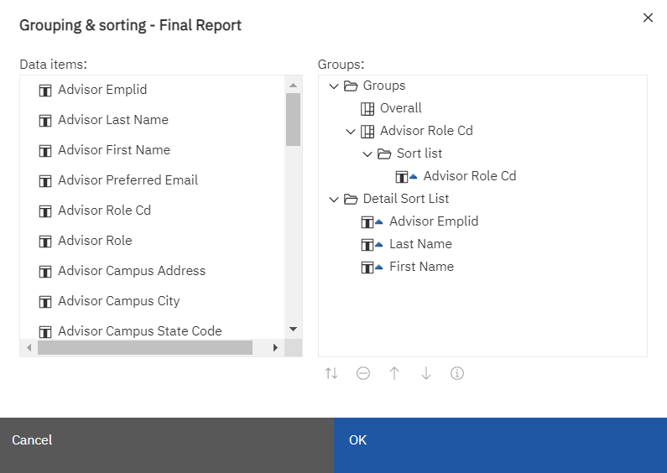

* + 1. If not already done, expand the Groups folder by clicking on the down arrow to the left of Groups. Continue expanding by clicking down arrows.
    2. Sorting can occur within a group. If a group has sorting, it will have a Sort List folder with one or more field names listed below.
    3. If not already done, expand the Detail Sort List folder by clicking on the down arrow to its left. It will display the fields that are sorted.
    4. Fields are listed in the order they are sorted from top to bottom.
    5. If a field has a triangle pointing up, it is in ascending order. If a field has a triangle pointing down, it is in descending order.
  1. Remove an existing grouping and any of its associated sorting by clicking on the desired field listed under Groups and then clicking the  Delete icon at the bottom of the box.
  2. Remove an existing sort by clicking on a field listed under Detail Sort List and then clicking the  Delete icon at the bottom of the box.
  3. To add a grouping, click on the Groups folder on the right, then on the left, double-click on the field to be grouped. It will display the field on the right at the end of any existing groups. It will also create a Sort List folder.
  4. If you want to add sorting to a group, click on the groups Sort List on the right, and on the left, double-click the field to be sorted.
  5. To sort on a field, click on the Detail Sort List on the right, then on the left, double-click on the field to be sorted. It will display the field at the end of the Detail Sort List.
  6. To change the order of the grouping or sort fields, click on a field name on the right, and at the bottom use the big  up arrow or the down arrow to move that field up or down in the list.
  7. To change a column to sort from ascending to descending or the reverse, click on the field and then at the bottom select the small  up and down arrows icon.
  8. Click the OK button at the bottom right to save changes.

# Create a Subscription (Schedule a Report)

In Cognos, users can schedule reports to automatically run and email the results. Cognos breaks this down into two functions: subscriptions and schedules. A report can only have one schedule and it can only be created by a Cognos administrator. On the other hand, any user with access to a report can create a subscription and can set over 20 subscriptions for a report.

**Limitations**

* A user can only schedule a report to run one or more days a week. There is no option to run a report monthly or yearly.
* The report can only be emailed to the user creating the subscription.

1. The report to be subscribed/scheduled has been run and is displaying in Cognos. If not, see the View a Report procedure to run a report.
2. On the black application bar, click the  More icon and select Subscribe from the dropdown. A right side bar with scheduling options is displayed. Note: there is another  More icon below the black one. This will not have the Subscribe option.

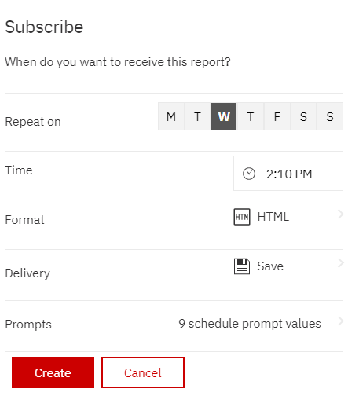

1. By default, the Subscribe side bar schedules the report to run for the current day of the week and time. This can be edited. Fill out the sidebar as follows:
   1. **Repeat On:** The letters displayed are for every day of the week starting with Monday. Click on the letter for every day of the week the report is to run. If the report is not to run today, unclick the letter for today since it is clicked by default.
   2. **Time:** Edit the time the report is to run for the day(s) selected.
   3. **Format:** Click on the faint arrow > to the right end of the format row to open a list of format options. Click the checkbox on one or more formats to be generated when the subscription runs. Click the Done button.
   4. **Delivery:** Click on the faint arrow > to the right end of the Delivery row to open a list of Delivery options. It is recommended to check the Send report by email checkbox, which expands with more options. From here click the Attach the report checkbox, and the Save Report checkbox. Click the Done button.
   5. **Prompts:** Click on the faint arrow > to the right end of the Prompts row to open a list of prompts. (A report may or may not have prompts). Review the prompts selected here. You may NOT change the prompts here.
      1. If the report the user wants to subscribe to should have different prompts, Click the <Back link at the top and then the Cancel button. Re-run the report with the desired prompts and start at the top of this procedure again to subscribe.
      2. If the prompts are the correct prompts for the report, click the <Back link and then the Create button.
2. If the user wants to schedule the report with these prompts to run at a different time, start at the top of the procedure and create another subscription.
3. If the user wants to schedule the report with different prompts, re-run the report with the desired prompts and start at the top of the procedure to create another subscription.

# View a Subscription

Once a user has subscribed to a report, the subscriptions can be edited or deleted. It is important for the user to review the subscription to be sure it is the subscription they want edited or deleted since there can be multiple versions of the same report with only (1), (2), etc. at the end of the name to distinguish between them.

1. At the far right on the black application task bar, click the  Personal Menu icon. A right sidebar will display.
2. Click on the My schedules and subscriptions link. The My schedules and subscriptions page will display in Current view. It may take a minute to fully display the page. There are four different views. See the My Schedules and Subscriptions Page Overview for details.
3. In the upper left of the page click the down arrow to the right of Current and select Schedule. It will show all the user’s subscriptions and schedules.

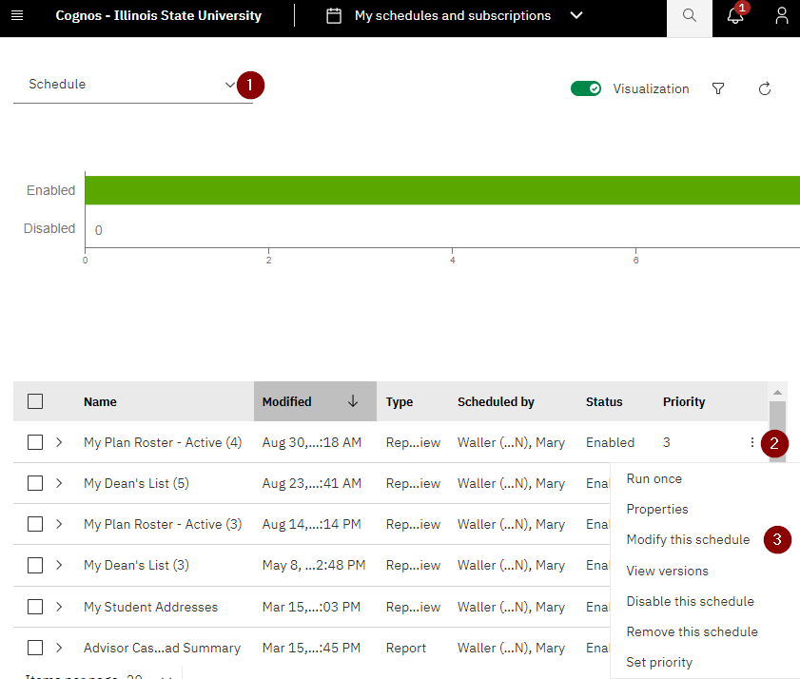

1. Find the subscription to be viewed using the tips below.
   1. Schedules and subscriptions are given the report name.
   2. All subscriptions are prefaced with the word “My” to distinguish them from schedules.
   3. If a report has more than one subscription, it will be displayed with (1), (2), (3), etc. at the end of the report name. This can be for multiple reasons.
      1. The user can create a subscription to run the same report, with the same prompts, multiple times a day. Each new subscription will get a number at the end after the first subscription is created.
      2. The user can create a subscription to run for the same report, with different prompts. Each new subscription will get a number at the end after the first subscription is created.
2. To tell the difference between a subscription that has (1), (2), or (3), etc. after the name the user needs to:
   1. Click on the  More Actions Menu icon at the end of the row and select Modify this schedule from the dropdown. (See the image above.)
   2. View the current setup for the report’s subscription in the sidebar. Click on Show Details link at the bottom to see the report’s prompts. Click the Cancel button in the bottom right when done reviewing.

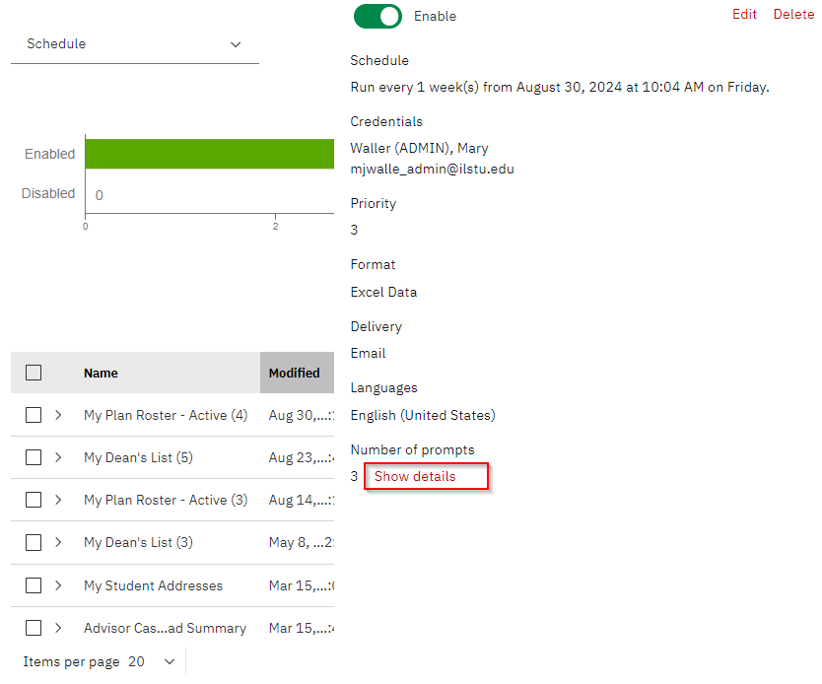

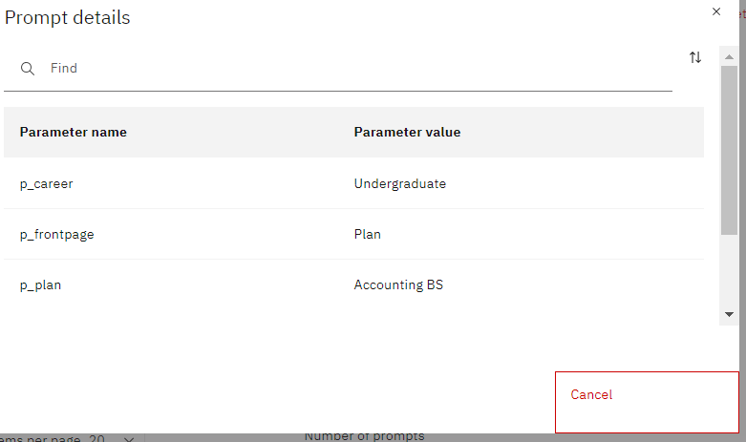

* 1. To see the report’s prompts and schedule in the same format as when creating a subscription, instead of clicking on the Show details link at the bottom of the page, click on the Edit link in the upper right. (See first image above.)
     1. Navigate by clicking through the tabs Schedule, Options and Prompts. Use the scroll bar on the right to move up and down the page. For each section (gray box) on the page, look for the up or down arrow at the bottom right of the section. Click the arrow up or arrow down icon to expand or shrink that section. See the Edit a Subscription for more details and screenshots of these tabs.
     2. Click Cancel when done reviewing so no changes are made to the subscription.
  2. Do this for each version of the subscription to find the subscription to be viewed.

# Edit a Subscription

Once a user has subscribed to a report, the subscriptions can be edited as explained below.

1. At the far right on the black application task bar, click the  Personal Menu icon. A right sidebar will display.
2. Click on the My schedules and subscriptions link. The My schedules and subscriptions page will display in Current view. It may take a minute to fully display the page. There are four different views. See the My Schedules and Subscriptions Page Overview for details.
3. In the upper left of the page, click the down arrow to the right of Current and select Schedule. It will show all the user’s subscriptions and schedules.



1. Find the subscription to be viewed using the tips below.
   1. Schedules and subscriptions are given the report name.
   2. All subscriptions are prefaced with the word “My” to distinguish them from schedules.
   3. If a report has more than one subscription, it will be displayed with (1), (2), (3), etc. at the end of the report name. This can be for multiple reasons.
      1. The user can create a subscription to run the same report, with the same prompts, multiple times a day. Each new subscription will get a number at the end after the first subscription is created.
      2. The user can create a subscription to run for the same report, with different prompts. Each new subscription will get a number at the end after the first subscription is created.
2. To tell the difference between a subscription that has (1), (2), or (3), etc. after the name the user needs to:
   1. Click on the  More Actions Menu icon at the end of the row and select Modify this schedule from the dropdown. (See image above.)
   2. View the current setup for the report’s subscription in the right sidebar. Click on Show Details link at the bottom to see the report’s prompts. Click the Cancel button in the bottom right when done reviewing.





* 1. Once you have found the subscription to be changed, or if you want more details about the subscription (you found it hard to determine if the selected subscription is the one you want to change), instead of clicking on the Show details link at the bottom of the page, click on the Edit link in the upper right. (See first image on last page.) The right sidebar will remain open, but on the left a new page is displayed with a Schedule, Options and Prompts tab. The schedule tab is selected.

On each tab there will be boxed sections with an up arrow at the bottom right. Use the arrow to expand or shrink that section. In addition, there can be a scroll bar on the bottom or right to view the entire tab.

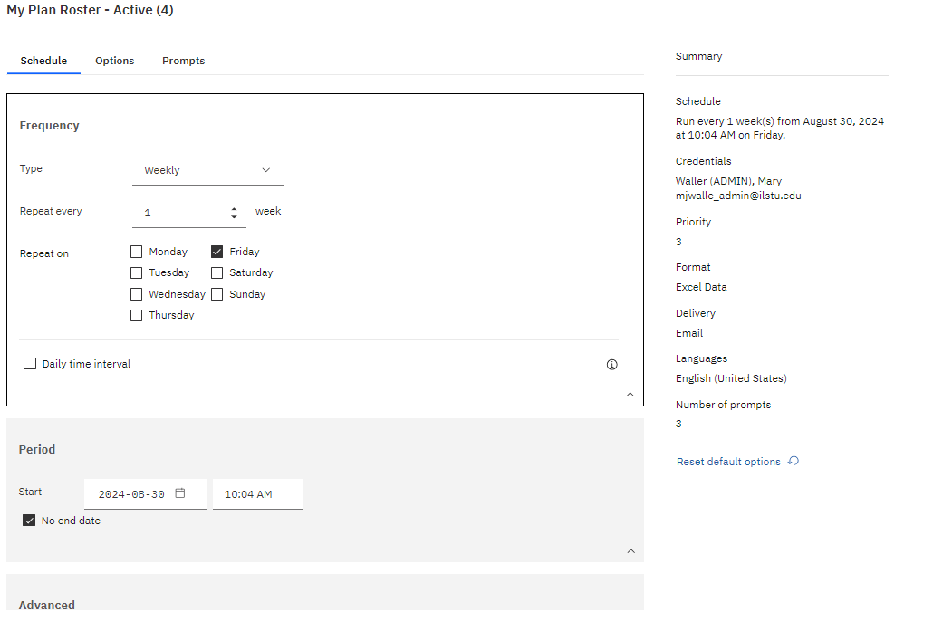

* + 1. On the Schedule tab, you can see the report’s scheduled frequency and date start and stop time.

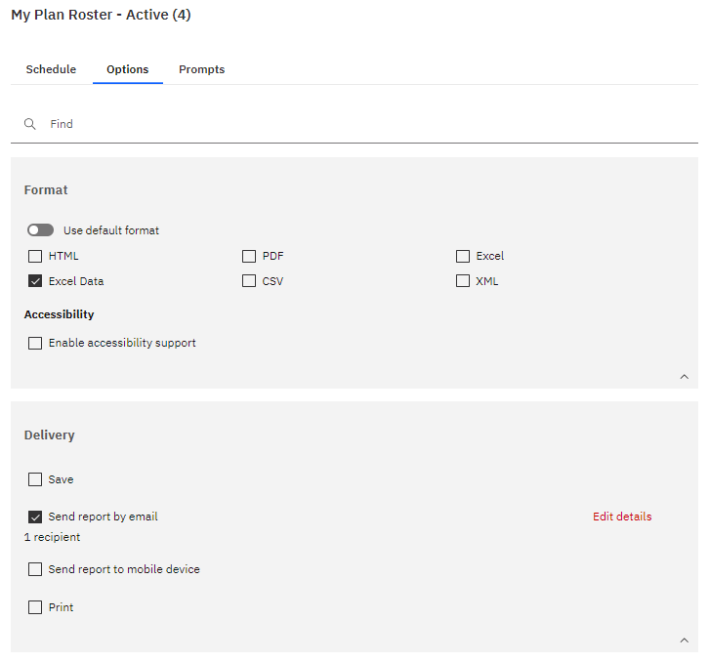

* + 1. Clicking on the Options tab will allow you to see the format of the report. Excel (shows report formatting and multiple pages) and Excel Data (tabular with no formatting).

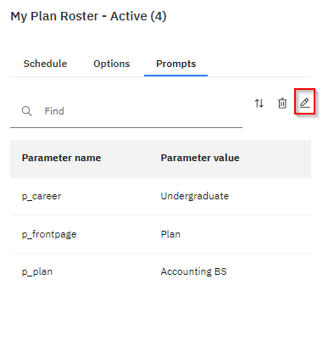

* + 1. Clicking on the Prompts tab will show you the prompts currently selected for your report. Since they can be difficult to interpret, click on the pencil and seen the prompt pages for your report as if you are running the report. Go through all prompt pages if there are more than one. You may have to scroll to be sure you see all selections. Multiple selections are possible for each prompt.

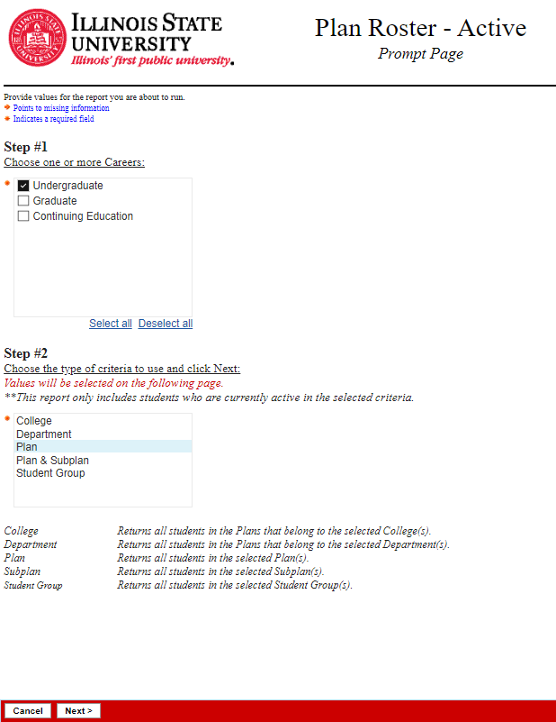

* + 1. Click Cancel when done reviewing so no changes are made to the subscription.
  1. Do this for each version of the subscription until you find the subscription to be edited.

1. Once the subscription to be edited has been identified,
   1. Click on the  More Actions Menu icon at the end of the subscription’s row and select Modify this schedule from the dropdown. (See first image in this procedure.)
   2. Click on the Edit link in the upper right to see tabs for all the subscription information.
   3. Navigate by clicking through the tabs as explained above, modifying the schedule, options and prompts selections.
2. Edit how often the report should be run, at what time, and change the start and end date for when the schedule should start and end on the Schedule tab. For example, you can set up a subscription to run every Monday at 7:00 am starting on March 1, 2024 through May 30, 2024.
3. To change the format of the report, click on the Options tab and make changes in the Format section. One or more formats can be checked here.
4. To add or change emailing options for the report, click on the Options tab, use the scroll bar on the right to go to the Delivery section. We do not recommend changing these options. If not already expanded, click the arrow icon on the bottom right of the box. Make changes to the delivery options if desired.
   1. EDA recommends users click on the Send Report by email checkbox if not already checked.
   2. Then to the right, click on the Edit Details link.
   3. Scroll to the bottom and if the Include Link toggle is not green, click on it so the report will be attached in your email.
   4. Do not add any email addresses in the To textbox. Only the user’s email should be entered in this textbox.
5. To change the prompts used for the report, click on the Prompts tab. It will display all the current prompt selections used when this report is run by the schedule.
   1. To change one or more prompts, click on the  pencil icon on the upper right side.
   2. It will display one or more prompt pages that are displayed when the report is run directly. Make new prompt selections on these pages. When the user has entered all prompts, the original screen with all the new selections are displayed.
6. Click the Save button in the bottom right of the screen to save all your changes.

# Delete a Subscription

1. At the far right on the black application task bar, click the  Personal Menu icon. A left sidebar will display.
2. Click on the My schedules and subscriptions link. The My schedules and subscriptions page will display in Current view. It may take a minute to fully display the page. There are four different views. See the My Schedules and Subscriptions Page Overview for details.
3. In the upper left of the page click the down arrow to the right of Current and select Schedule. It will show all the user’s subscriptions and schedules.



1. Find the subscription to be deleted using the tips below.
   1. Schedules and subscriptions are given the report name.
   2. All subscriptions are prefaced with the word “My” to distinguish them from schedules.
   3. If a report has more than one subscription, it will be displayed with (1), (2), (3), etc. at the end of the report name. This can be for multiple reasons.
      1. The user can create a subscription to run the same report, with the same prompts, multiple times a day. Each new subscription will get a number at the end after the first subscription is created.
      2. The user can create a subscription to run for the same report, with different prompts, at the same time as another subscription. Each new subscription will get a number at the end after the first subscription is created.
2. To tell the difference between a subscription that has (1), (2), or (3), etc. after the name the user needs to:
   1. Click on the  More Actions Menu icon at the end of the row and select Modify this schedule from the dropdown. (See image above.)
   2. View the current setup for the report’s subscription in the sidebar. Click on Show Details at the bottom to see the report’s prompts. See the View a Subscription or Edit a Subscription procedure for more details on identifying a specific subscription using the Edit link.
   3. Do this for each version of the subscription to find the subscription to be deleted.
3. Once the subscription to be deleted is identified, click the  More icon at the right end of the row and select the Remove this schedule from the dropdown. The subscription is removed from the page and will no longer run.

# View and Interact with a Dashboard

1. Click on the  Open Menu icon in the upper left-hand corner on the black application bar and click .
2. If not already underlined, click on Team Content.
3. Click on folders to navigate through the file hierarchy to get to the dashboard desired. It may be necessary to scroll to find the folder or dashboard. Select the package name such as Student Records or Admissions, and then click Dashboards. See the Find/Search for a Report procedure if the dashboard cannot be found.
4. Click on the dashboard name to open it. It may take a little time to load.

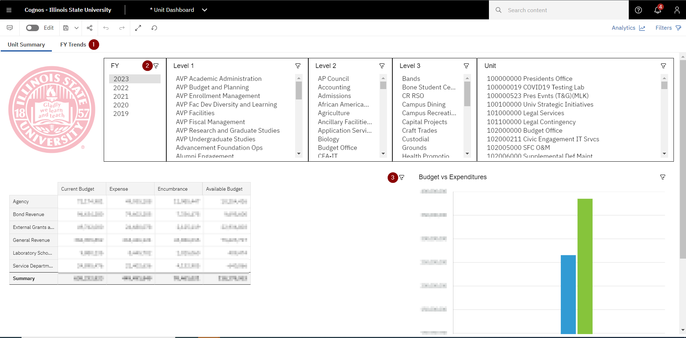

1. At the top left of the report are the tab headings. Click on tab headings to go from one page to another in the dashboard.
2. Under the tabs are the prompts users can change. For example, select a different fiscal year or term. This can be done for all the filters at the top. On some dashboards, to save space, the user must click on the filter icon to see a popup box to display other filter options. When the user makes changes the impacted visualizations below are automatically updated.
3. Each visualization may have a filter icon in the upper right-hand corner. Click on the filter to open it up and see filters implemented for that visualization. A user cannot change these filters.
4. When the user is done viewing the dashboard, on the black application taskbar, click the Items Opened icon next to Illinois State University text and when the dropdown appears click the X to the right of the dashboard name. The message box below is displayed.

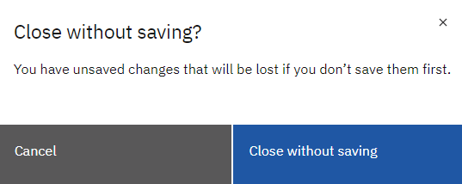

1. Click the Close without saving button to close the dashboard.

# Request Access to Cognos

1. On a web browser, go to ithelp.illinoisstate.edu
2. Click on Get IT Help in the red toolbar.
3. Scroll to the bottom right under Requests and click the Submit Detailed Request link. The Cherwell login page is displayed.
4. Enter your Illinois State University username and password and click the Log In button. The IT Help Service Portal is displayed.
5. Look for a Request or Change Access link. Not all employees see this link. (It is an issue that is being researched.)
6. If you can see the Request or Change Access link, click on the link and fill out the form as follows:
   1. **Short Description:** Leave the default text as is.
   2. **Description/Additional Comments:** Leave the default text as is:
   3. **Preferred Phone:** Enter your phone number.
   4. **Do you wish to add, modify or remove access:** Select Add.
   5. **For which service:** Select Cognos Business Intelligence from the dropdown. Don’t type it in!
   6. Review and click Yes for any packages you want access to. When Yes is checked, a Detail Business Need box is displayed. Provide one or two sentences for the reason you need access to the package. For example, “I am an advisor who needs access to admissions information for students I work with.”
   7. A separate business need must be entered for each package you want to access. If appropriate, the same business need can be copied and pasted multiple times.
   8. If Other is selected, in the Business case box, also add what other packages, not listed above, you want access to before typing your business need.
   9. Scroll up to the top and click the Save button on the right side of the screen.
7. If you do not have the Request or Change Access link, send an email to the Technology Support Center at [supportcenter@ilstu.edu](mailto:supportcenter@ilstu.edu).
   1. In the subject header enter, “Request Access to Cognos”
   2. In the message enter the packages you want to be able to access.
   3. For each package requested, enter a business need. Provide one or two sentences for the reason you need access to the package. For example, “I am an advisor who needs access to admissions information for students I work with.”
   4. A separate business need must be entered for each package you want to access. If appropriate, the same business need can be copied and pasted multiple times.
8. You will receive a ticket from the Technology Support Center. Please be patient. It will take a few days to reach out to the data stewards to get their approval before you can be provided access.
9. Once access has been determined, you will receive an email letting you know if access has been granted or not.

# Where to Get Help

Contact Enterprise Data & Analytics (EDA)

* Email: [eda@ilstu.edu](mailto:eda@ilstu.edu)
* Website: <https://data.illinoisstate.edu/reports-dashboards/cognos/>
  + Information about packages/reports
  + Changes and upcoming releases
  + Additional training resources including videos

Contact the Technology Support Center (TSC) for additional help

* Phone: 438-HELP (4357)
* Email: [supportcenter@ilstu.edu](mailto:supportcenter@ilstu.edu)